**Difference between FDMA, TDMA and CDMA**

**1. Frequency Division Multiple Access (FDMA) :**  
FDMA is a type of channelization protocol. In this bandwidth is divided into various frequency bands. Each station is allocated with band to send data and that band is reserved for particular station for all the time which is as follows :

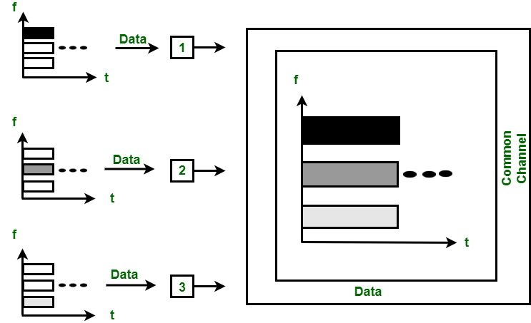

*Figure – FDMA*

The frequency bands of different stations are separated by small band of unused frequency and that unused frequency bands are called as guard bands that prevents the interference of stations. It is like access method in data link layer in which [data link layer](https://www.geeksforgeeks.org/design-issues-in-data-link-layer/) at each station tells its physical layer to make a band pass signal from the data passed to it. The signal is created in the allocated band and there is no physical multiplexer at the physical layer.

**2. Time Division Multiple Access (TDMA) :**  
TDMA is the channelization protocol in which bandwidth of channel is divided into various stations on the time basis. There is a time slot given to each station, the station can transmit data during that time slot only which is as follows :

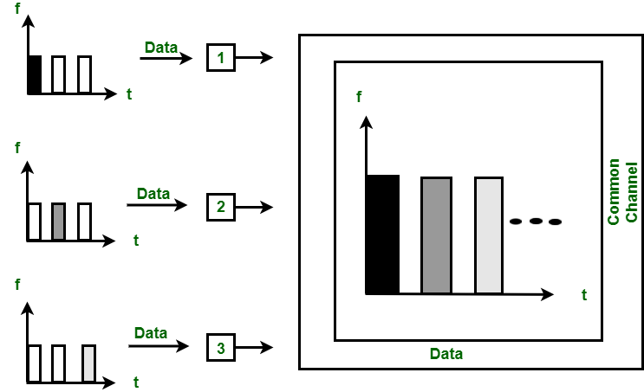

*Figure – TDMA*

Each station must aware of its beginning of time slot and the location of the time slot. TDMA requires synchronization between different stations. It is type of access method in the data link layer. At each station data link layer tells the station to use the allocated time slot.

**3. Code Division Multiple Access (CDMA) :**  
In CDMA, all the stations can transmit data simultaneously. It allows each station to transmit data over the entire frequency all the time. Multiple simultaneous transmissions are separated by unique code sequence. Each user is assigned with a unique code sequence.

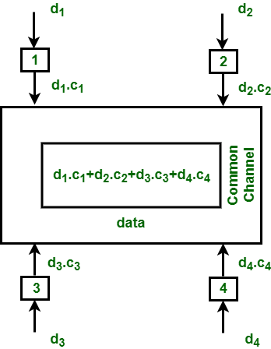

*Figure – TDMA*

In the above figure, there are 4 stations marked as 1, 2, 3 and 4. Data assigned with respective stations as d1, d2, d3 and d4 and the code assigned with respective stations as c1, c2, c3 and c4.

**Difference between FDMA, CDMA and TDMA :**

| FDMA | TDMA | CDMA |
| --- | --- | --- |
| FDMA stands for Frequency Division Multiple Access. | TDMA stands for Time Division Multiple Access. | CDMA stands for Code Division Multiple Access. |
| In this, sharing of bandwidth among different stations takes place. | In this, only the sharing of time of satellite transponder takes place. | In this, there is sharing of both i.e. bandwidth and time among different stations takes place. |
| There is no need of any codeword. | There is no need of any codeword. | Codeword is necessary. |
| In this, there is only need of guard bands between the adjacent channels are necessary. | In this, guard time of the adjacent slots are necessary. | In this, both guard bands and guard time are necessary. |
| Synchronization is not required. | Synchronization is required. | Synchronization is not required. |
| The rate of data is low. | The rate of data is medium. | The rate of data is high. |
| Mode of data transfer is continuous signal. | Mode of data transfer is signal in burts. | Mode of data transfer is digital signal. |
| It is little flexible. | It is moderate flexible. | It is highly flexible. |

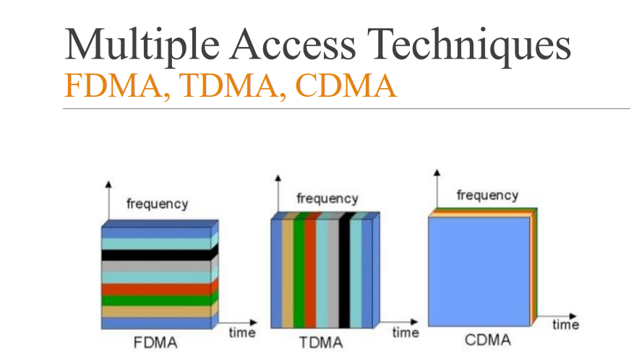

### **CSMA (Carrier Sense Multiple Access)**

It is a **carrier sense multiple access** based on media access protocol to sense the traffic on a channel (idle or busy) before transmitting the data. It means that if the channel is idle, the station can send data to the channel. Otherwise, it must wait until the channel becomes idle. Hence, it reduces the chances of a collision on a transmission medium.

**CSMA Access Modes**

**1-Persistent:** In the 1-Persistent mode of CSMA that defines each node, first sense the shared channel and if the channel is idle, it immediately sends the data. Else it must wait and keep track of the status of the channel to be idle and broadcast the frame unconditionally as soon as the channel is idle.

**Non-Persistent:** It is the access mode of CSMA that defines before transmitting the data, each node must sense the channel, and if the channel is inactive, it immediately sends the data. Otherwise, the station must wait for a random time (not continuously), and when the channel is found to be idle, it transmits the frames.

**P-Persistent:** It is the combination of 1-Persistent and Non-persistent modes. The P-Persistent mode defines that each node senses the channel, and if the channel is inactive, it sends a frame with a **P** probability. If the data is not transmitted, it waits for a (**q = 1-p probability**) random time and resumes the frame with the next time slot.

**O- Persistent:** It is an O-persistent method that defines the superiority of the station before the transmission of the frame on the shared channel. If it is found that the channel is inactive, each station waits for its turn to retransmit the data.

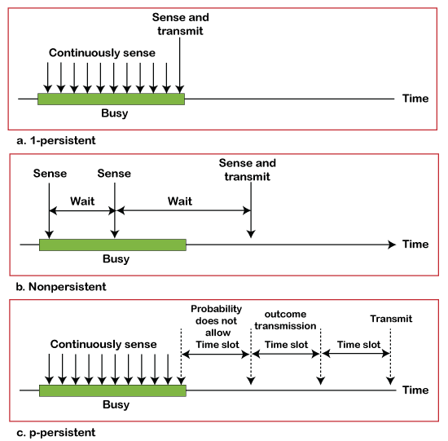

### **CSMA/ CD**

It is a **carrier sense multiple access/ collision detection** network protocol to transmit data frames. The CSMA/CD protocol works with a medium access control layer. Therefore, it first senses the shared channel before broadcasting the frames, and if the channel is idle, it transmits a frame to check whether the transmission was successful. If the frame is successfully received, the station sends another frame. If any collision is detected in the CSMA/CD, the station sends a jam/ stop signal to the shared channel to terminate data transmission. After that, it waits for a random time before sending a frame to a channel.

### **CSMA/ CA**

It is a **carrier sense multiple access/collision avoidance** network protocol for carrier transmission of data frames. It is a protocol that works with a medium access control layer. When a data frame is sent to a channel, it receives an acknowledgment to check whether the channel is clear. If the station receives only a single (own) acknowledgments, that means the data frame has been successfully transmitted to the receiver. But if it gets two signals (its own and one more in which the collision of frames), a collision of the frame occurs in the shared channel. Detects the collision of the frame when a sender receives an acknowledgment signal.

**OFDM**

**Orthogonal Frequency Division Multiplexing** (OFDM) is a digital multi-carrier modulation scheme that extends the concept of single subcarrier modulation by using multiple subcarriers within the same single channel. ... OFDM is based on the well-known technique of Frequency Division Multiplexing (FDM).

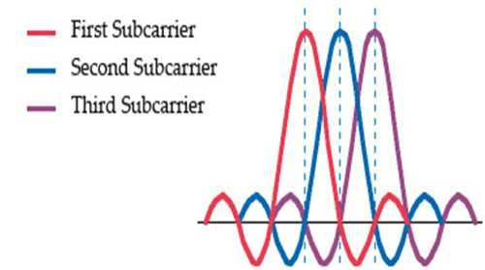

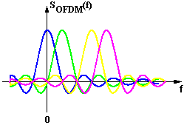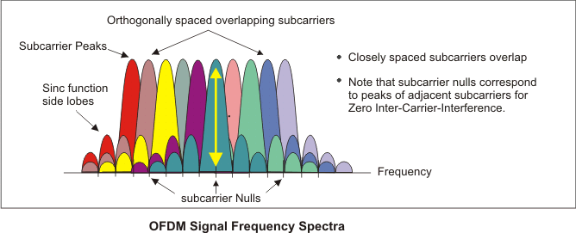

How OFDM Works?

OFDM: Orthogonal Frequency Division Multiplexing, is **a form of signal modulation that divides a high data rate modulating stream placing them onto many slowly modulated narrowband** close-spaced subcarriers, and in this way is less sensitive to frequency selective fading.

What is OFDM used for?

Orthogonal frequency division multiplexing (OFDM) is a modulation technique that is used in several applications ranging from cellular systems (3GLTE, WiMAX), wireless local area networks (LANs), **digital audio radio, underwater communications**, and even optical light modulation.